C:\Users\DELL\AppData\Local\Microsoft\Windows\INetCache\Content.Word\logo.png

Project Name : Health Care

Faculty : sir syad Asad un nabi

**ACKNOWLEDGMENT**

We are really grateful because we managed to complete our project within the time given by our teacher

Sir syad Assad. This assignment cannot be completed without the effort and co-operation from our teacher, Group members;

We also sincerely thank our teacher for the guidance and encouragement in finishing this project and also for teaching us in this course.

Last but not the least, we would like to express we gratitude to our friends and respondents for the support and willingness directly or indirectly to spend some times with me to fill in the questionnaires.

**CONTENT**

* Introduction------------------------------------------------
* Objectives of the Project------------------------------
* Problem Statement--------------------------------------
* Work Analysis----------------------------------------------
* Design -------------------------------------------------------
* Header -------------------------------------------------------------
* Navigation Bar ---------------------------------------------------
* Footer --------------------------------------------------------------
* Home Page -----------------------------------------------
* specialization----------------------------------------------
* Category----------------------------------------------------
* Contact Us ------------------------------------------------
* About Us --------------------------------------------------------

**Introduction**

The thirst for learning, upgrading technical skills and applying the concepts in real life environment at a fast pace is what the industry demands from IT professionals today. However busy work schedules, far-flung locations, unavailability of convenient time-slots pose as major barriers when it comes to applying the concepts into realism. And hence the need to look out for alternative means of implementation in the form of laddered approach.

The above truly pose as constraints especially for our students too! With their busy schedules, it is indeed difficult for our students to keep up with the genuine and constant need for integrated application which can be seen live especially so in the field of IT education where technology can change on the spur of a moment. Well, technology does come to our rescue at such times!!

Keeping the above in mind and in tune with our constant endeavour to use Technology in our training model, we at Aptech have thought of revolutionizing the way our students learn and implement the concepts using tools themselves by providing a live and synchronous eProject learning environment!

**Objectives of the project**

The Objective of this program is to give a sample project to work on real life projects. These applications help you build a larger more robust application.

The objective is not to teach you JavaScript/Dreamweaver but to provide you with a real life scenario and help you create basic applications using the tools.

You can revise the chapters before you start with the project.

This project is meant for students who have completed the module of ***Dreamweaver***. These programs should be done in the Lab sessions with assistance of the faculty if required.

It is very essential that a student has a clear understanding of the subject. Students should go through the project and solve the assignments as per requirements given.

Kindly get back to eProjects Team in case of any doubts regarding the application or its objectives.

TOPIC OF OUR PROJECT: Health Care

**PROBLEM STATEMENT:**

**Requirement Specification:**

The Web site is to be created based on the following requirements.

The administrator should be able to do the following:

a) Add cities to the master database.

b) Add doctors to the master database.

c) Modify doctor Details.

d) Modify patient Details.

e) Delete Cities.

f) Delete Patient.

g) Delete Docotor.

h) Manage/ Manage Users/Logins.

i) Manage information/details on the WEBSITE.

The Doctor should be able to do the following:

a) Login into the system with his Users/Password.

b) View his/her Profile details.

c) Add details on his/her profile.

d) Modify his/her profile.

e) View appointments.

f) Update his availability for DAY/WEEK/MONTH.

The Patient should be able to do the following:

a) Register/Creat Account [USERID should be unique].

b) Search Doctor based on Location Speialist.

c) Book Appointments [Check Availability].

**WORK ANALYSIS**

|  |  |  |  |
| --- | --- | --- | --- |
| Task | Ali Hassan | Arslan | Shaiza |
| Analysis |  |  |  |
| Design |  |  |  |
| Coding |  |  |  |
| Testing |  |  |  |
| Documentation |  |  |  |

**Home Page Design:**

|  |  |  |
| --- | --- | --- |
| Logo | Navbar | Log out |
| Picture Slider | | |
| About | | |
| Application | | |
| Footer | | |

**View:**



**Header:**

**You can easily search different doctors and specialties here by entering their names.**

**The Names Are:**

|  |  |
| --- | --- |
| **Doctor** | **Specialties** |
| doctorhassan | Clinical |
| doctorali | Biological |
| doctorkaka | Endocrinology |
| doctormubeen | Internal |
| doctordaisy | Allergology |

1. **Home Page:**

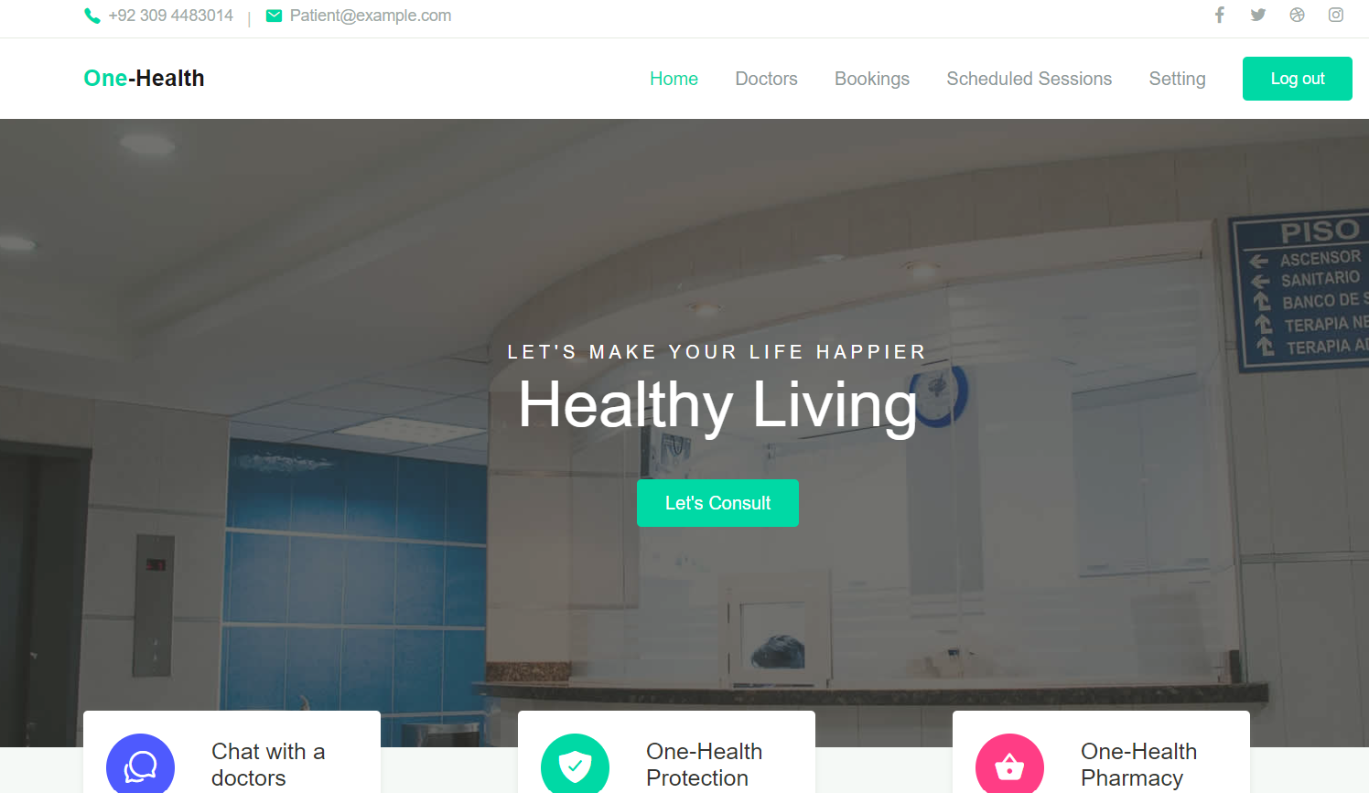

2. About:



**3. Register**

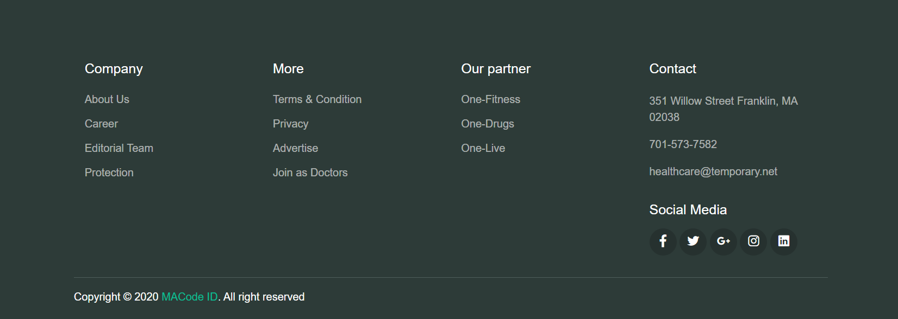

1. **Register**

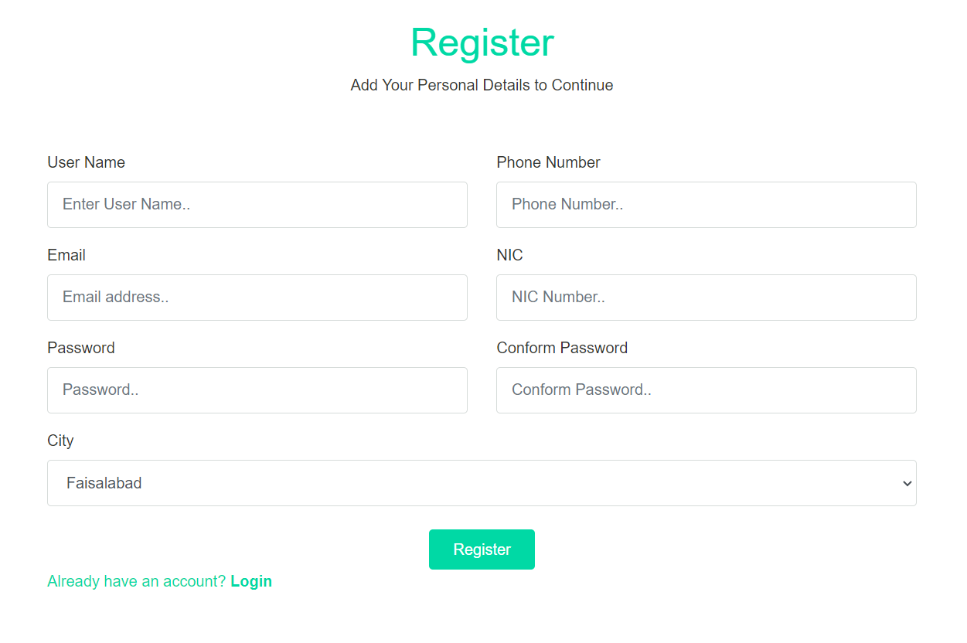

**5. Login**

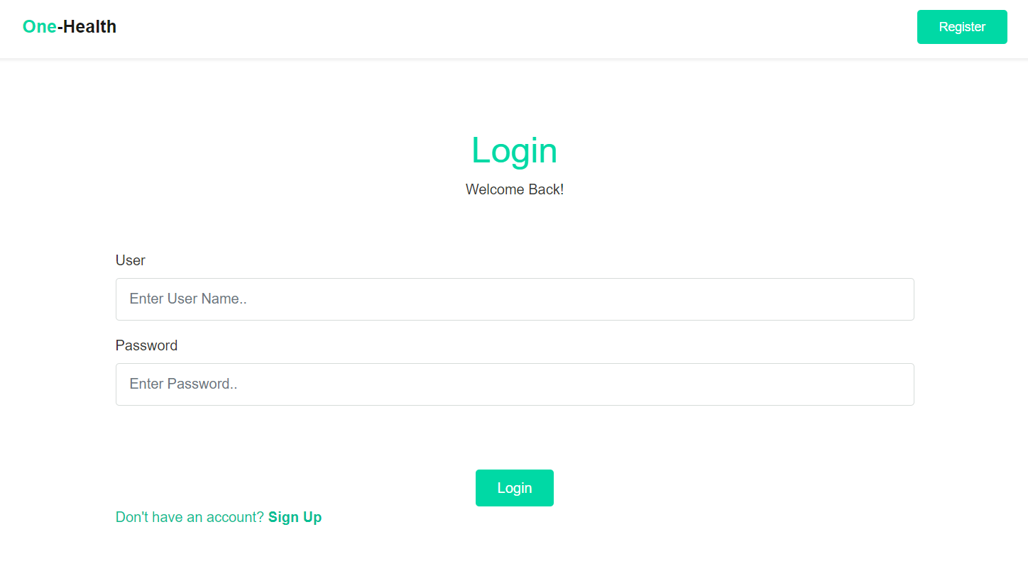

**6. Doctor**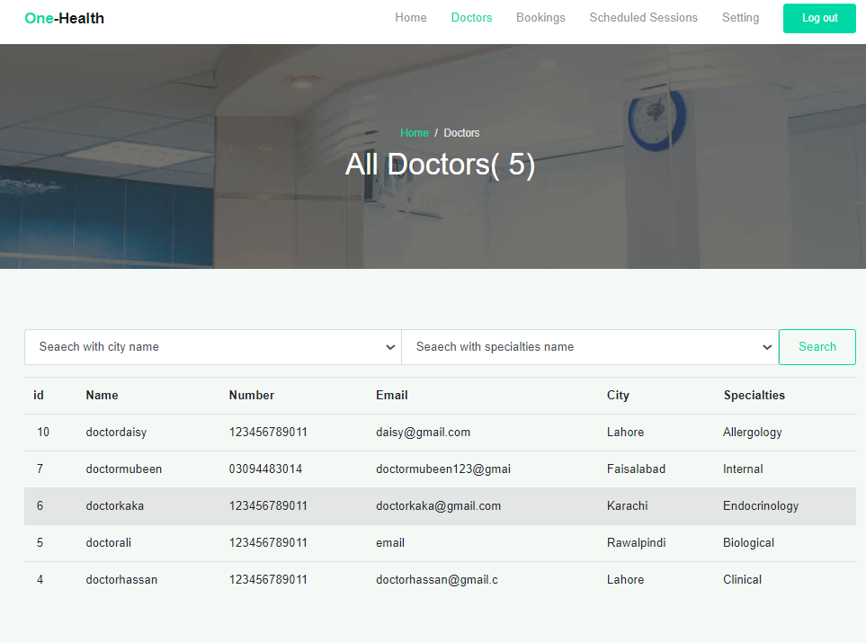

**6. My Bookings**

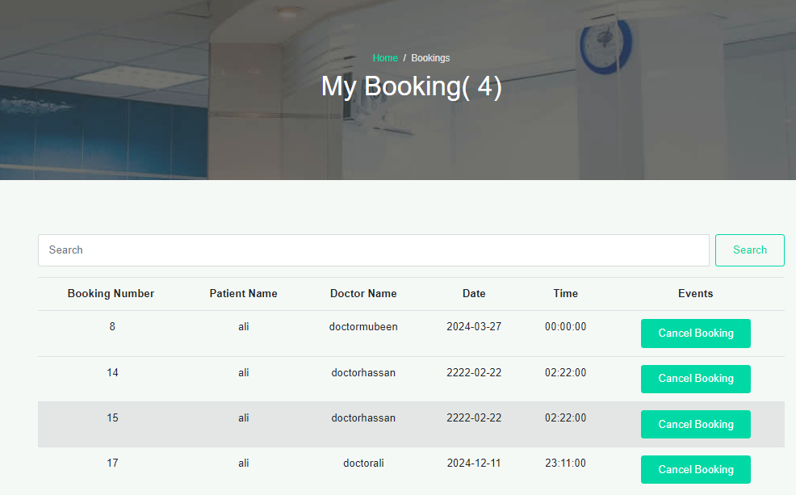

**5. My Profile**

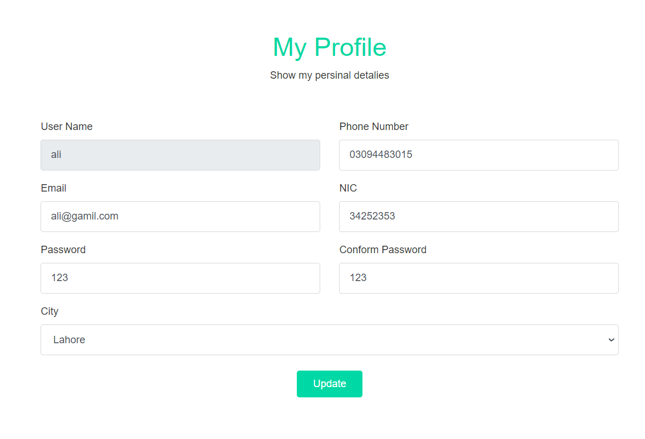

Form Code:

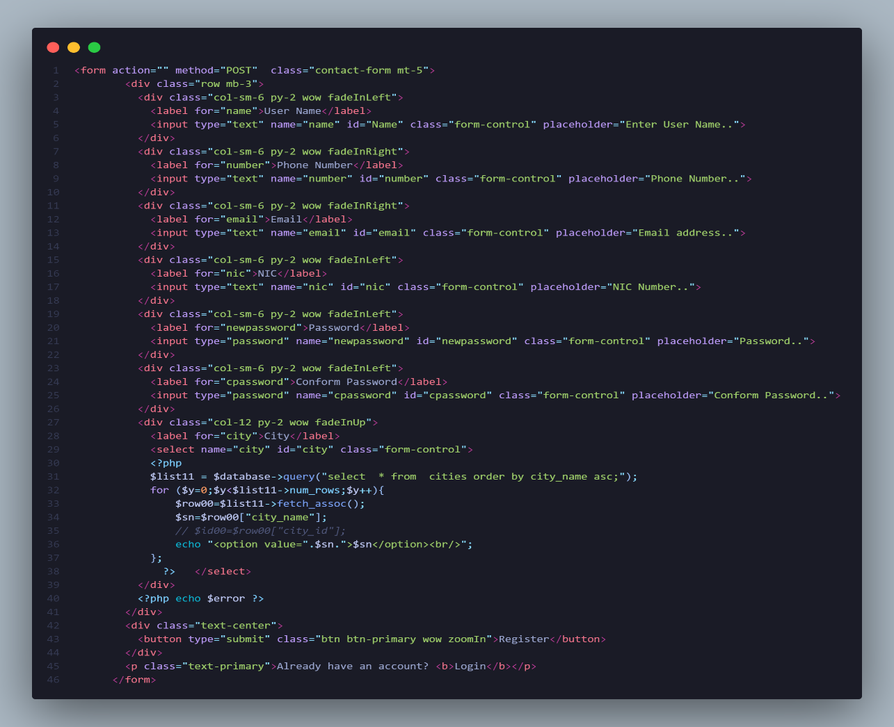

Form Validation Code: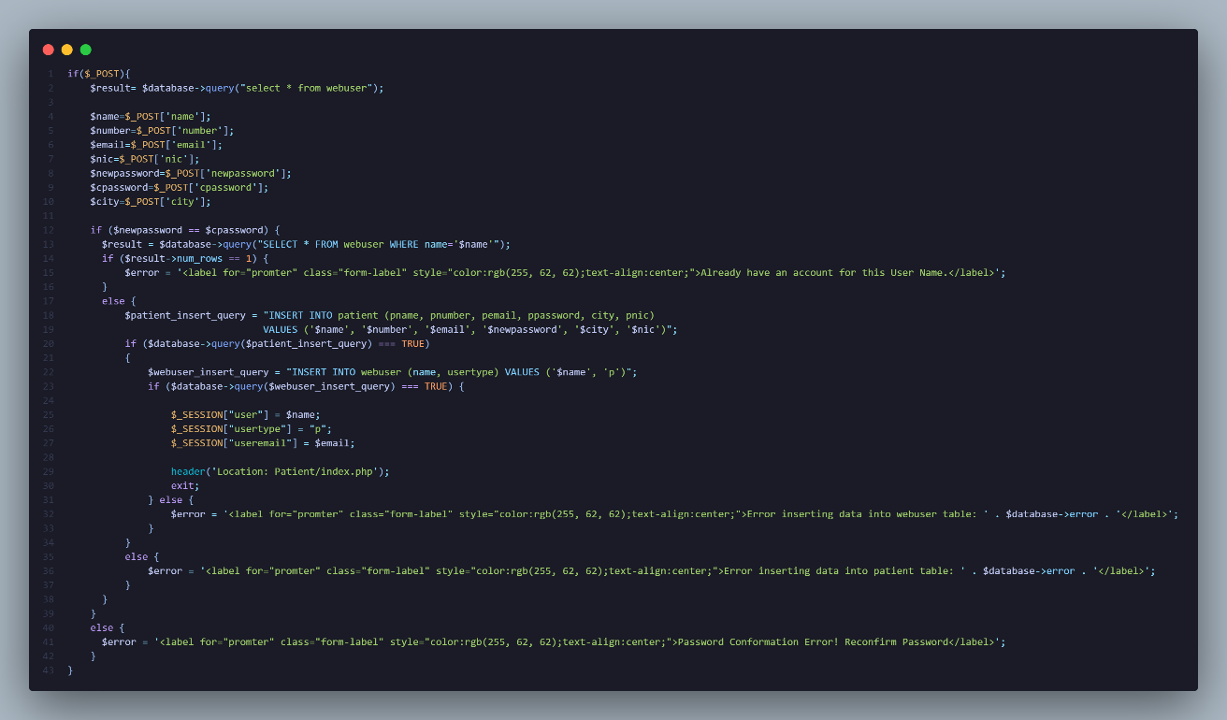

Admin Panel:

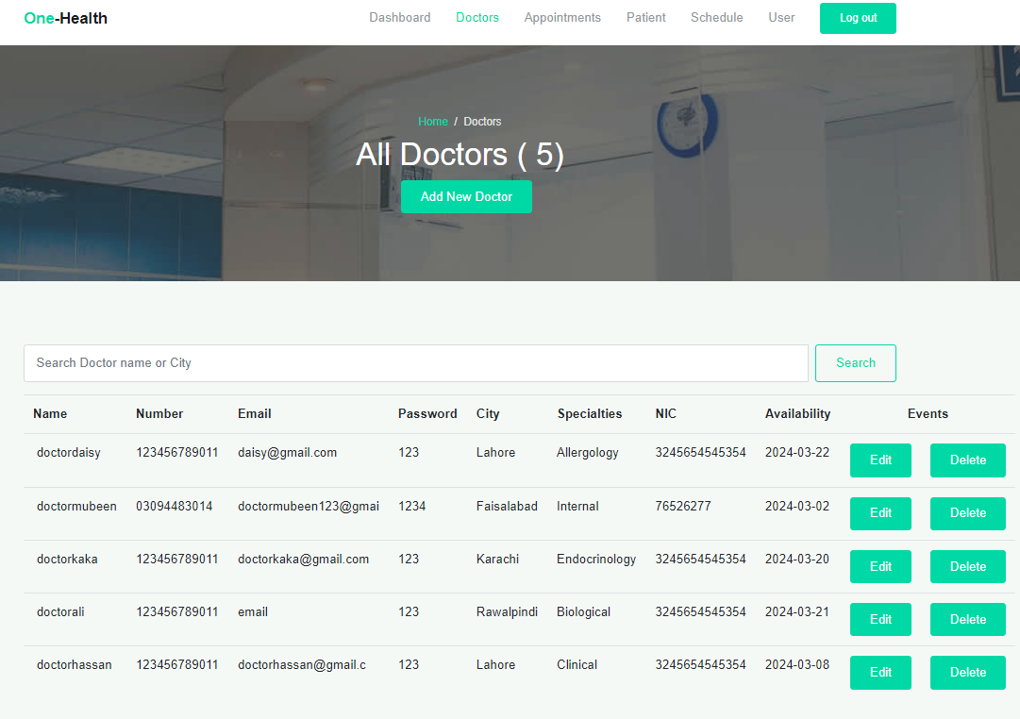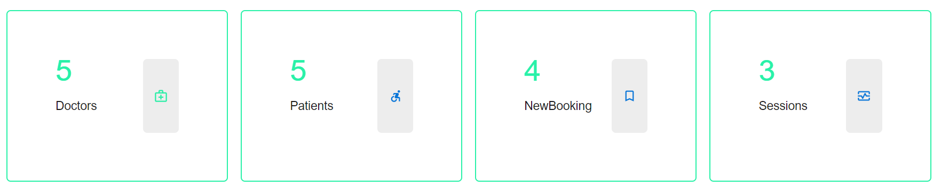

code: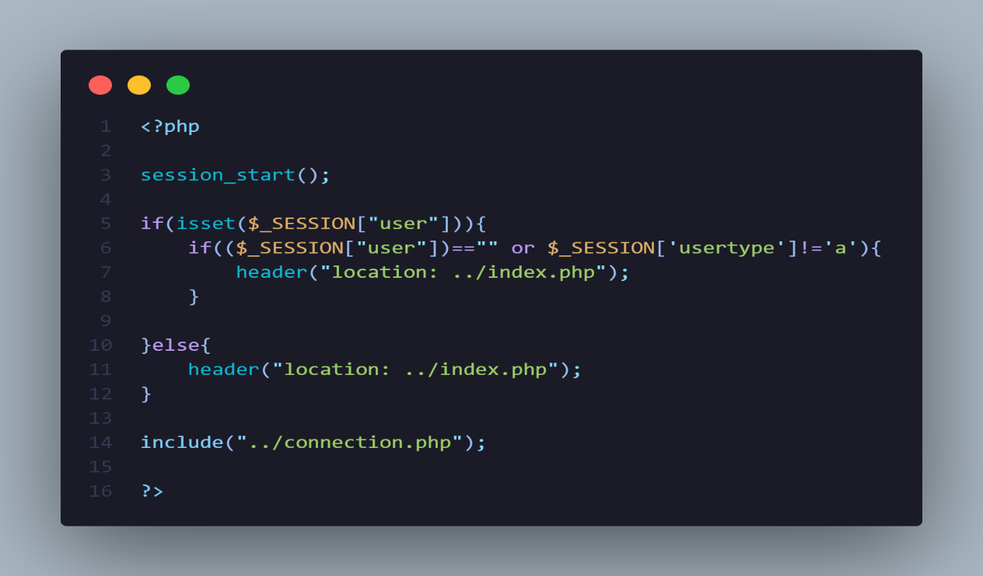

Doctor Panel:

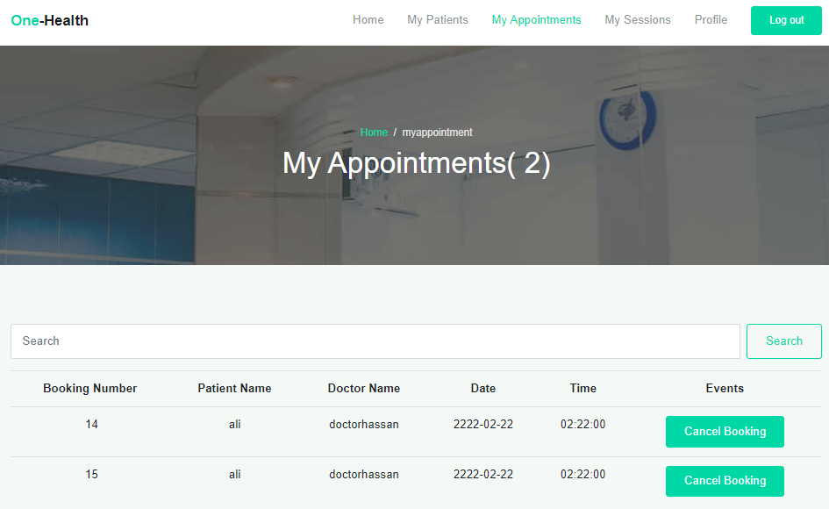code:

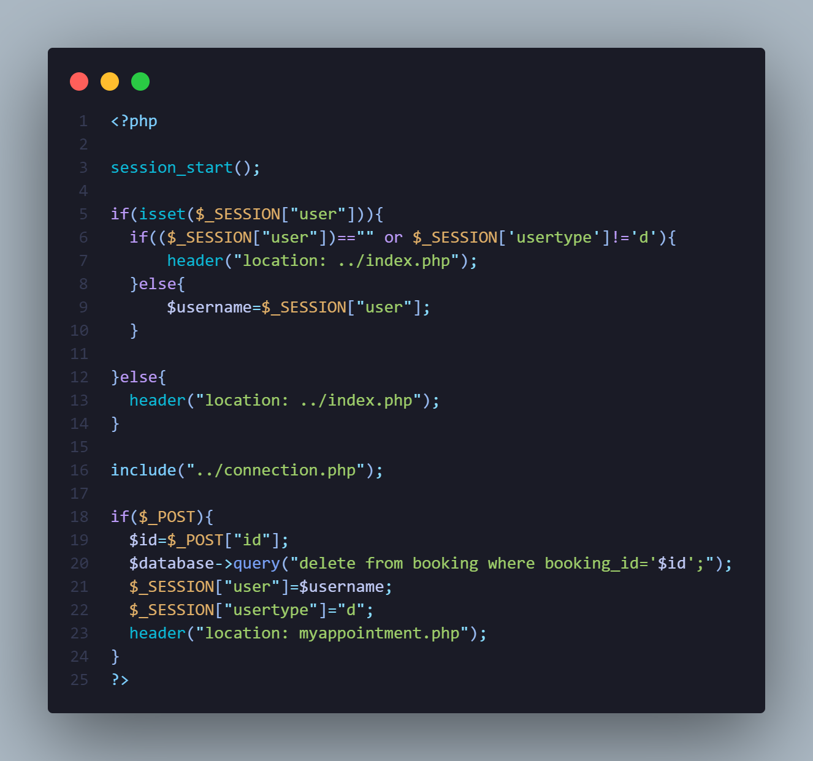

Patient Panel:

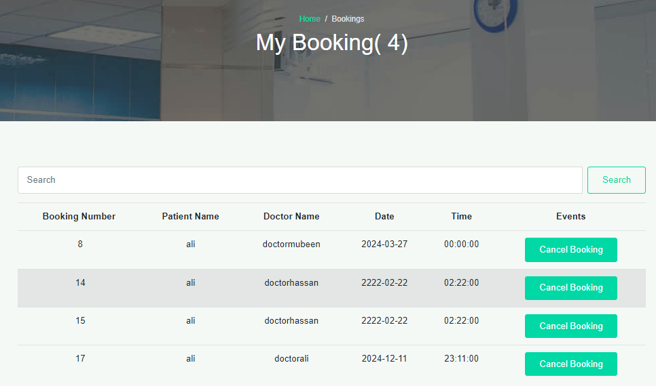

Code: 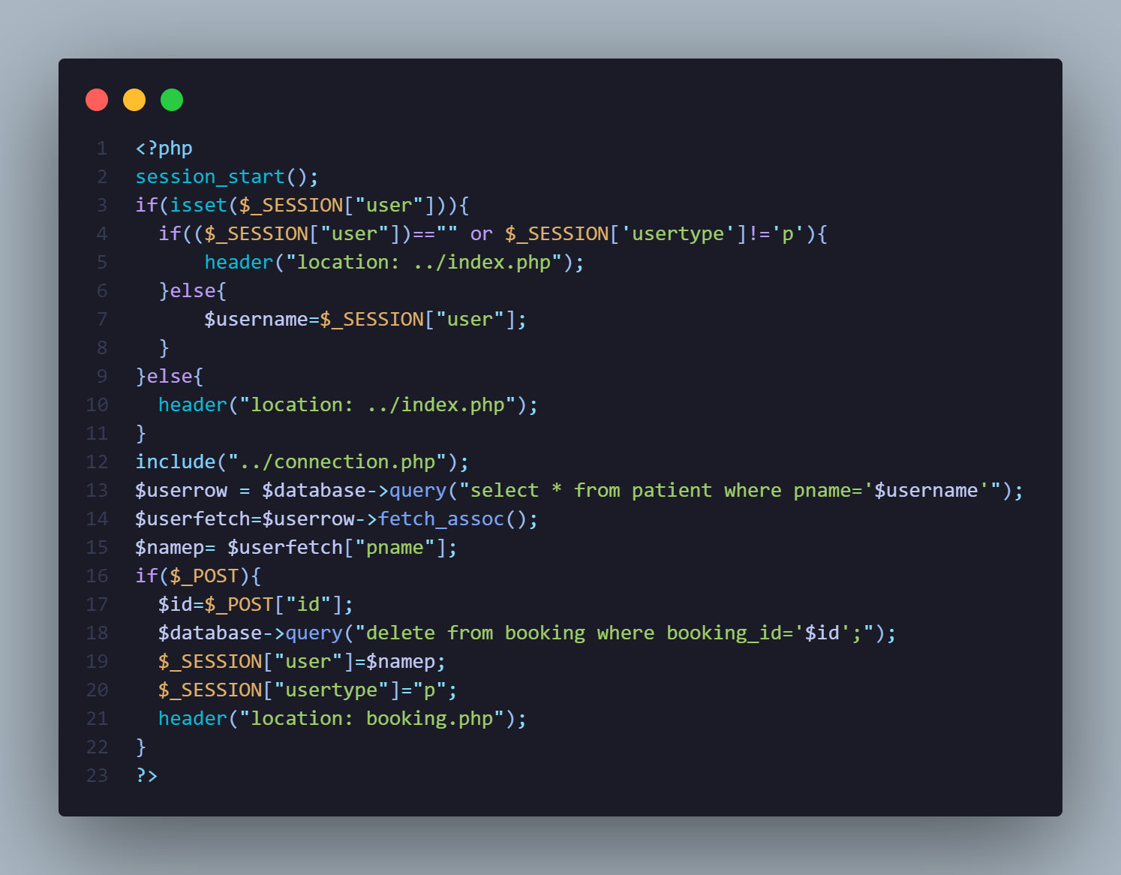

THANK YOU